|  |  |
| --- | --- |
| TEAM ID | PNT2022TMID20252 |
| Project Name | IoT Based smart crop Protection system for agriculture |
| Maximum mark | 20 marks |

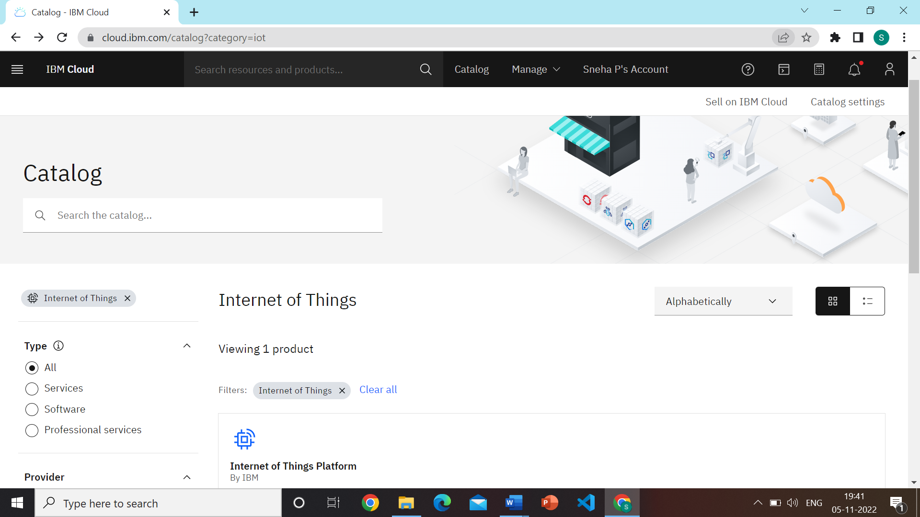

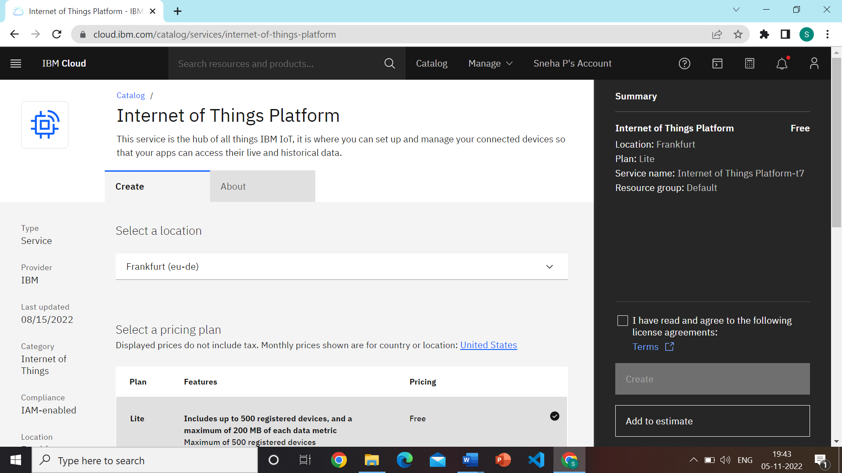

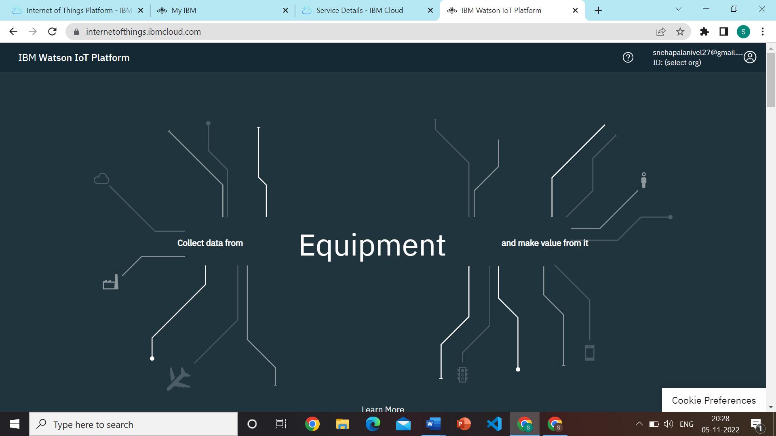

Device credentials information

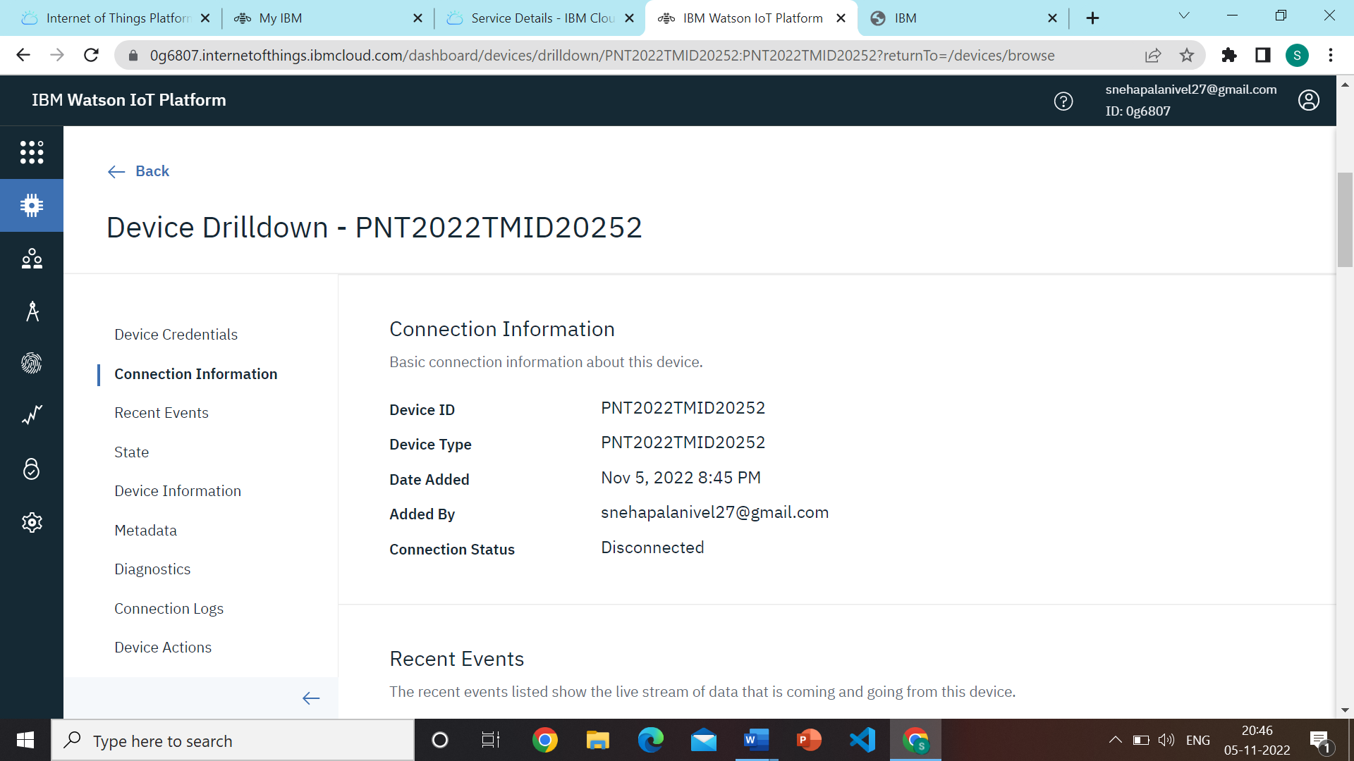

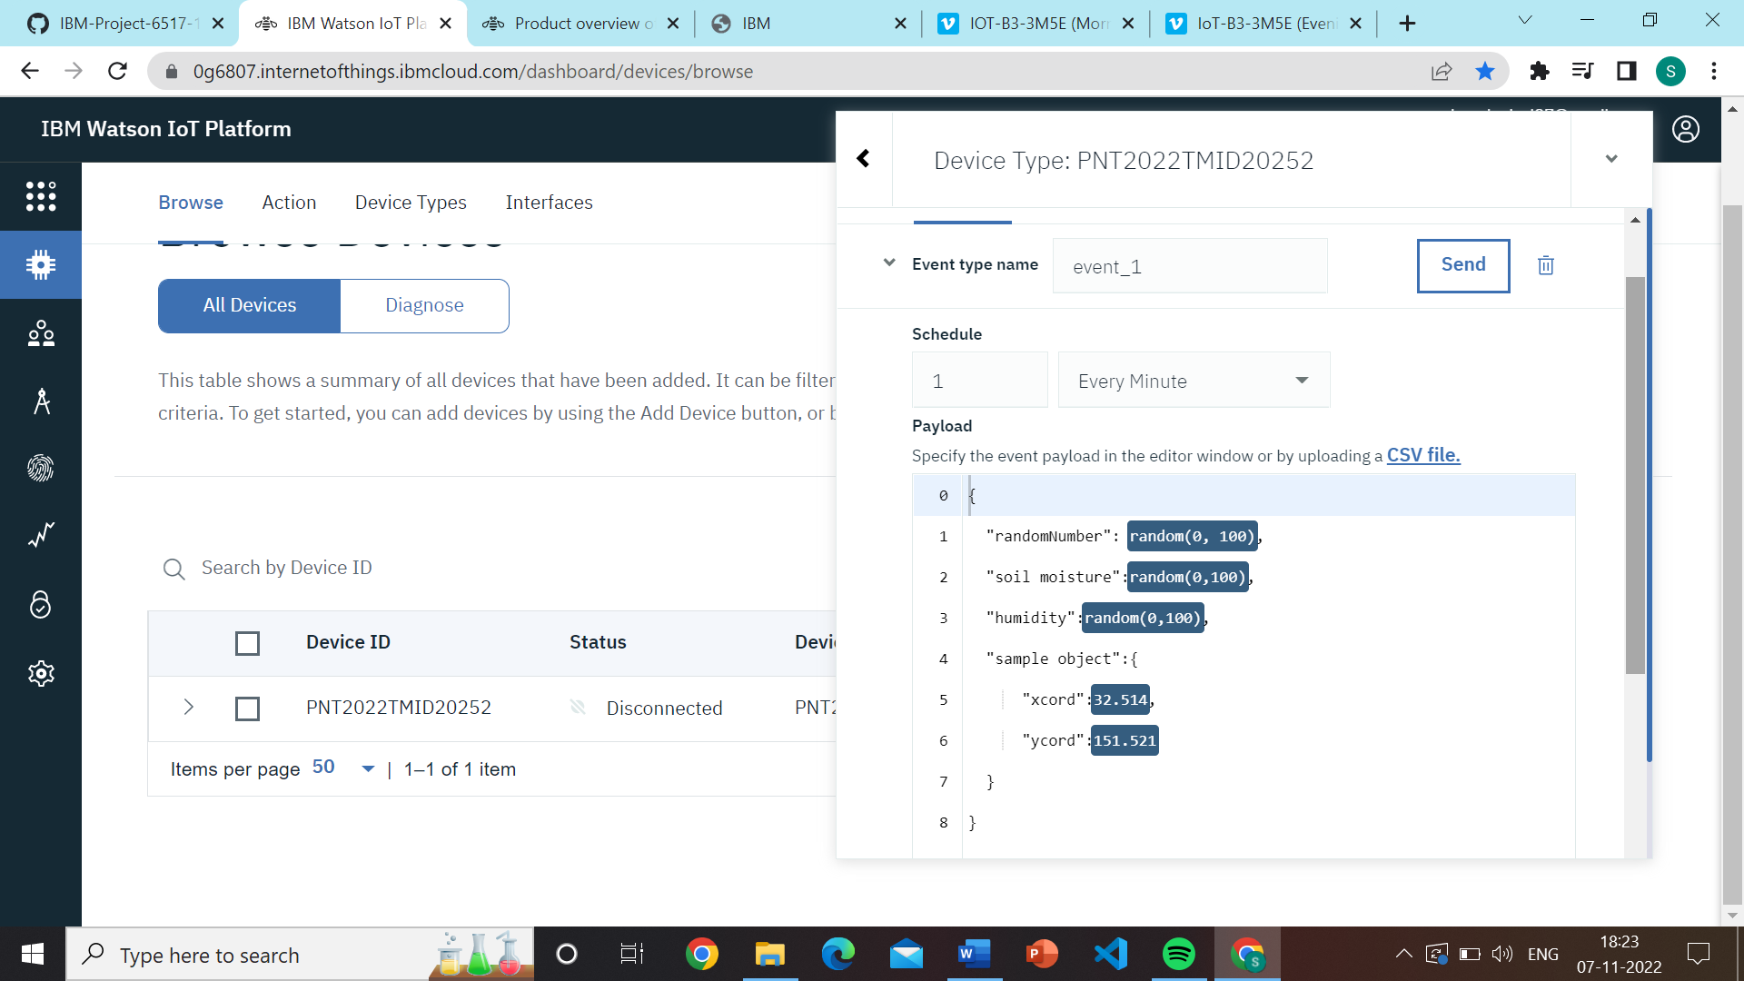

OUTPUT:

